ALCOHOL SENSING AND ENGINE LOCKING SYSTEM

V. Dinesh, R. Ajay Raghav , S. Kirthik kumar, T.Gowsik

Electronics and communication engineering

M Kumarasamy collage of engineering

**Abstract**— This project presents the design and implementation of an Alcohol Detection with Engine Locking for cars using the Arduino NANO and MQ 3 sensor. The system will continuously monitor level of alcohol concentration in alcohol detection sensor and thus turn off the engine of vehicle if the alcohol concentration is above threshold level. The model will also send the message of whereabouts of the vehicle. The project provides an efficient solution to control accidents due to drunk driving. There is therefore the need for an alcohol detection system that can function without the restriction of space and time. The investigation done by the Planet Health Organization in 2008 shows that concerning 50%-60% of traffic accidents square measure associated with drink-driving.

KEY WORDS: Arduino NANO , MQ-3 Sensor, LED, DC Motor, relay module etc...

# INTRODUCTION

The current situation shows that the most of accidents are occurring due to drunk-drive .The drivers who drives alcohol are not on stable condition. This alcohol detection system works on a simple principle if the driver has been drinking the alcohol breath analyser senor will detect the level of alcohol if the driver have drink a alcohol are not .This is project is designed for the safety of the people seating inside or outside of the vehicle. There is therefore the need for an alcohol detection system that can function without the space and time. And we are going to developing a auto locking system. The drivers who drink alcohol are not in an stable condition and so, rash driving occurs on highway which can be risky to the lives of the people on road, the driver inclusive. The enormity of the dangerous driving transcends boundary. The laws in India are currently prohibiting drivers to drink and drive so that the fine can stop them to drink and drive. Whatsoever, effective observation of inebriated drivers could be a challenge to the policemen and road safety officers, the rationale for this stems from the natural inability of citizenry to be present additionally as state among identical house and time. This restricted ability of enforcement agents undermines each manual effort geared toward edge drink-driving. There is therefore the need for an alcohol detection system that can function without the restriction of space and time.

# LITERATURE SURVEY

[1]. I. Fletcher et al proposed “Alcohol sensing and engine locking system”

“IEEE TRANSACTIONS ON INFORMATION FORENSICS AND SECURITY – 2018.

Now-a-days, mobile phone is used mostly by all people with internet usage are also at all.so these mobile phone also provide communication platform as they are equipped with 2G or 3G network. There are lots of cause of accident of car and they are drunkenness of driver, drowsiness of driver, unconsciousness of driver, and many time what happen driver is not responsible for accident but their (car) neighbouring car behaviour also have made role to enforce accident. [1]

There are also some system have been implemented to avoid accident but that do not give proper solution to implement in car to avoid various accidents that they are normally being happen. For example, when driver at speed suppose 80 km/h suddenly stop ignition system may lead to chances of dangerous accident. In IR sensor was used to detect obstacle which comes in front of this sensor(vehicle), and when obstacle detected vehicle was stop. [2]

It was also monitoring the toxic gases such as CO2, LPG, Alcohol from inside area of the vehicle. If there is high content of gases, then SMS had been send to authorized person to notify only. It describes a real-time online prototype driver-fatigue monitor.[3]

It uses remotely located charge coupled-device cameras which was equipped with active infrared illuminators to acquire video images of the driver.which is expensive when compared to Arduino nano.[4] Also, this system has a limited scope is usage because it can work only with 2 wheelers and not with any other segment of vehicle. However, our system can be integrated to not only 2 wheelers, but also with any kind of vehicle thereby preventing more accidents and saving more people.[5]

PROPOSED METHODOLOGY

Using Arduino nano, we propose to design a system consisting of an alcohol sensor, MQ3, to detect the presence of alcohol by analyzing a person’s breath and shutting down the vehicle’s engine when a specific amount of alcohol is detected to prevent any kind of mishap or accident that may occur due to the driver taking control over the vehicle. Hence, drunken driving is controlled, thereby minimizing the loss of life and property.

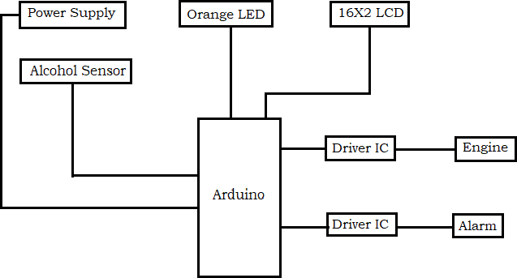

**FIG 1. HARDWARE MODULES**

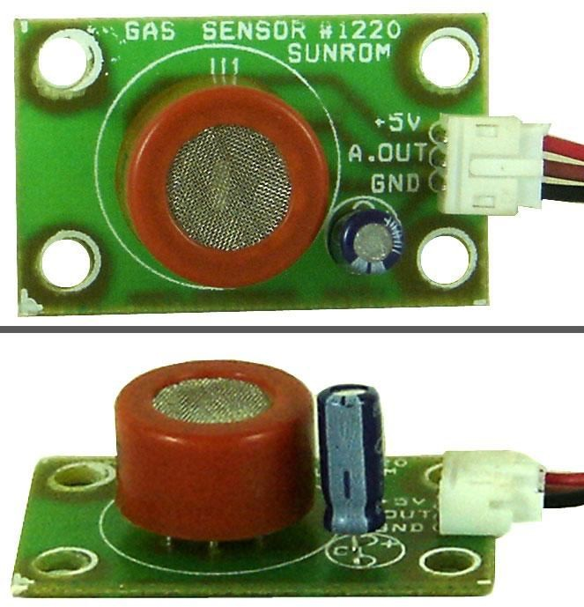The system consists of an Arduino nano, which acts as a controller for every component which is used. The microcontroller is connected to a LCD, an alcohol sensor, a buzzer, a DC motor, a LED and is powered by a DC power supply of 5 volts. As soon as the system is ON, the LCD displays “No Alcohol detected” and the vehicle engine gets started. As soon as the alcohol sensor detects alcohol, the LED starts to blink, the buzzer starts, the engine is switched OFF and the LCD displays “Alcohol Detected”.

Ardunio nano

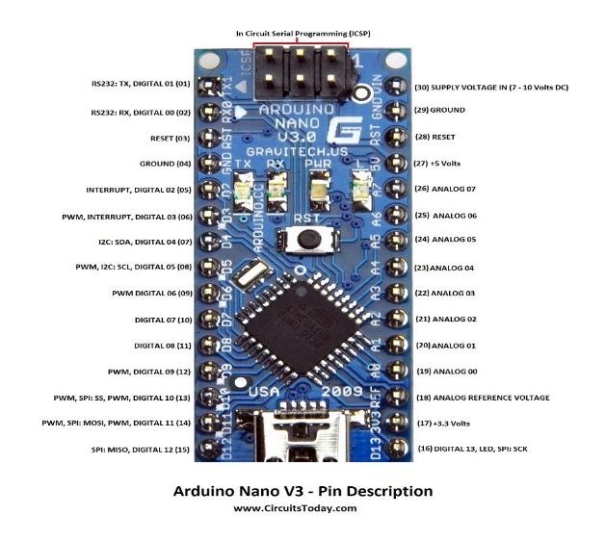

Fig 2.Ardunio nano

The Arduino Nano is a small, complete, and breadboard-friendly [board](https://en.wikipedia.org/wiki/Single-board_microcontroller) based on the [ATmega328P](https://en.wikipedia.org/wiki/ATmega328) released in 2008. It offers the same connectivity and specs of the [Arduino Uno](https://en.wikipedia.org/wiki/Arduino_Uno) board in a smaller form factor.

The Arduino Nano is equipped with 30 male [I/O](https://en.wikipedia.org/wiki/I/O) headers, in a [DIP-30](https://en.wikipedia.org/wiki/Dual_in-line_package)-like configuration, which can be programmed using the [Arduino](https://en.wikipedia.org/wiki/Arduino) Software [integrated development environment](https://en.wikipedia.org/wiki/Integrated_development_environment) (IDE), which is common to all Arduino boards and running both online and offline. The board can be powered through a [type-B mini-USB](https://en.wikipedia.org/wiki/USB_hardware#Connectors) cable or from a 9 V battery. Arduino being open sourced, has a really good community which makes development very convenient and any kind of problems are taken care of by the community. We are using it because it is open sourced and hence very cheap as compared to conventional microcontrollers. It can handle a large number of operations making it very convenient to use.

MQ 3 SENSOR

At pin A0, we connect the MQ3 alcohol sensor. It is one of the most accurate and mostly used alcohol sensor. This sensor can detect the presence of alcohol up to a range of 2 meters thereby making the detection process much accurate. Also, the sensitivity can be adjusted according to needs, making the sensor more versatile.

Fig3.MQ3 sensor

At pin A0, we connect the MQ3 alcohol sensor. It is one of the most accurate and mostly used alcohol sensor. This sensor can detect the presence of alcohol up to a range of 2 meters thereby making the detection process much accurate. Also, the sensitivity can be adjusted according to needs, making the sensor more versatile.

Relay module

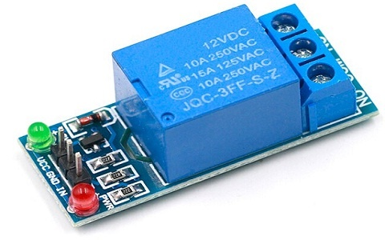

# Fig 4 relay module

A **relay** is an [electrically](https://en.wikipedia.org/wiki/Electric) operated [switch](https://en.wikipedia.org/wiki/Switch). It consists of a set of input terminals for a single or multiple control signals, and a set of operating contact terminals. The switch may have any number of contacts in multiple [contact forms](https://en.wikipedia.org/wiki/Electrical_contact#Contact_form), such as make contacts, break contacts, or combinations. Relays are used where it is necessary to control a circuit by an independent low-power signal, or where several circuits must be controlled by one signal. Relays were first used in long-distance circuits as signal repeaters. Relays were used extensively in telephone exchanges and early computers to perform logical operations.  Relays with calibrated operating characteristics and sometimes multiple operating coils are used to protect electrical circuits from overload or faults. A power of relay module is an electrical switch that operated by an electro magnet .. The electromagnet is activated by a separate by low power signal from a micro controller. When activated the electromagnet pulls to either open pr close an electrical circuit.

DUAL SHAFT DC MOTOR

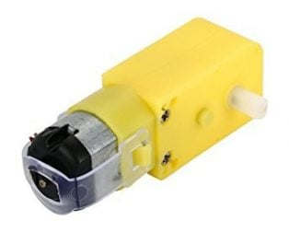

Fig 5.dual shaft dc motor

A **DC motor** is any of a class of rotary [electrical motors](https://en.wikipedia.org/wiki/Electrical_motor) that converts direct current (DC) electrical energy into mechanical energy. The most common types rely on the forces produced by induced magnetic fields due to flowing current in the coil. Nearly all types of DC motors have some internal mechanism, either electromechanical or electronic, to periodically change the direction of current in part of the motor. DC motors were the first form of motors widely used, as they could be powered from existing direct-current lighting power distribution systems. A DC motor's speed can be controlled over a wide range, using either a variable supply voltage or by changing the strength of current in its field windings. Small DC motors are used in tools, toys, and appliances. A coil of wire with a current running through it generates an [electromagnetic](https://en.wikipedia.org/wiki/Electromagnetic) field aligned with the center of the coil. The direction and magnitude of the magnetic field produced by the coil can be changed with the direction and magnitude of the current flowing through it.

A simple DC motor has a stationary set of magnets in the [stator](https://en.wikipedia.org/wiki/Stator) and an [armature](https://en.wikipedia.org/wiki/Armature_(electrical_engineering)) with one or more windings of insulated wire wrapped around a soft iron core that concentrates the magnetic field. The [universal motor](https://en.wikipedia.org/wiki/Universal_motor), a lightweight [brushed](https://en.wikipedia.org/wiki/Brush_(electric)) motor used for portable power tools and appliances can operate on direct current and alternating current.

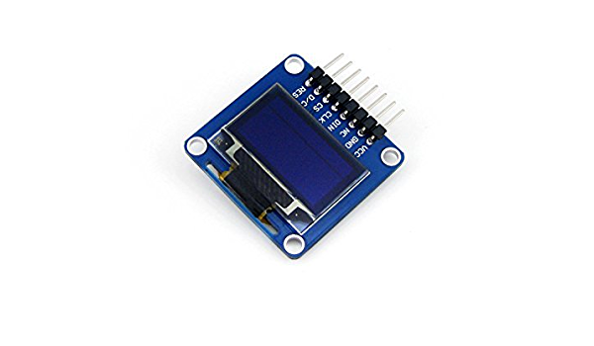 14X2 LCD DISPLAY

# Fig 7.6 14X2 LCD DISPLAY

A 14X2 LCD is a device which is used for displaying any message in the form of text and numbers. They can be easily programmed and can be used with different microcontrollers. They are preferred over seven segment display due to the ease of their use and convenience. A 14X2 LCD has 2 registers, command and data. Command registers store the command instructions given to the LCD. A command is an instruction given to LCD to do a predefined task like initializing it, clearing its screen, setting the cursor

position, controlling display etc. Data registers store the data to be displayed on the LCD. The data is the ASCII value of the character to be displayed on the LCD. In our project, LCD plays a very important role of displaying information related to the current status of the system.

**ADVANTAGES**

1. The chance of loss of life and property due to drunken driving is minimized.
2. Simple implementation leads to accurate results.
3. Can be implemented on various types of vehicles.
4. Less accidents, more safety.

APPLICATIONS

# 

1. This system can be implemented in vehicles to avoid accidents due to drunken driving.

2.It can also be used by various organizations or authorities to monitor its employees and keep a check on them.

RESULT

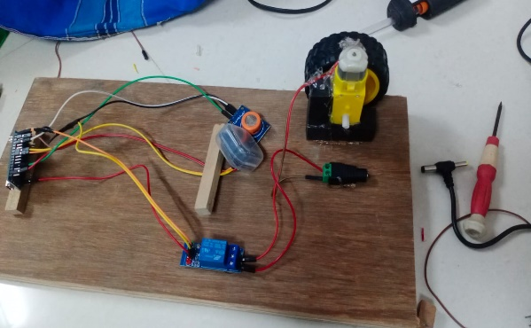

Whenever a drunk person tries to take control of vehicle, the alcohol sensor will detect the presence of alcohol and if presence of alcohol is detected by the sensor, it will shut down the vehicle’s engine and sound an alarm thereby alerting the nearby people. The LCD screen present in the vehicle will display “Alcohol Detected” so that people are aware of the situation and hence can take the necessary action that may be required. Therefore, by using this system on a vehicle, any kind of loss of life or damage to property can be avoided. Simulation of the system has been done in Proteus software. All the components have been tested and connected as required thereby providing us with the desired result as shown in the above image.

# CONCLUSION

In this project, we have developed an efficient system to tackle the menace of drunken driving. Our main aim is to minimize the loss of lives and property which happen due to drunken driving. This system once implemented on a large scale

will prove to be really helpful by shutting down the vehicle’s engine and alerting the nearby people before any mishap takes place. The sensor used in the project is very accurate and can be configured according to the requirements thereby increasing the efficiency.

REFERENCES

1. Lea Angelica Navarro, Mark Anthony Diño, Exechiel Joson, Rommel Anacan, Roberto Dela Cruz Electronics Engineering
2. Lea Angelica Navarro, Mark Anthony Diño, Exechiel Joson, Rommel Anacan, Roberto Dela Cruz Electronics Engineering
3. Lea Angelica Navarro, Mark Anthony Diño, Exechiel Joson, Rommel Anacan, Roberto Dela Cruz Electronics EngineeringLea Angelica Navarro, Mark Anthony Diño, Exechiel Joson, Rommel Anacan, Roberto Dela Cruz Electronics Engineering
4. Lea Angelica Navarro, Mark Anthony Diño, Exechiel Joson, Rommel Anacan, Roberto Dela Cruz Electronics Engineering